
Figure 1
SCHOOL OF TECHNOLOGY
BACHELOR OF SCIENCE IN INFORMATION TECHNOLOGY
UNIT: BIT 04105
TITLE:KCAU ONLINE VOTING SYSTEM
KAREN NJOKI KIARA
23/04687
Email: 2304687@students.kcau.ac.ke

(PROJECT PROPOSAL)

SUPERVISED BY: DR. EDWIN OMOL

FINAL YEAR PROJECT

This PROJECT PROPOSAL is submitted IN PARTIAL FULFILMENT OF THE REQUIREMENTS OF the award of BACHELORS OF SCIENCE IN INFORMATION TECHNOLOGY in KCA University

DECLARATION
This project is my original work and has not been presented for a degree in any other University
Name: …………………………………………………....

……………………….…. ………………….
Signature Date

This project has been submitted for examination with my approval as University Supervisor
Name: ………………………………………………………
……………………… ………………………
Signature Date

APPROVALS

Agree to Advise:
(Signature of Faculty Advisor)
Date Submitted: Date Approved:
Approved by:

Table of Figures
Figure 1 1
Figure 2 16
Figure 3 17
Figure 4 17
Figure 5 18
Figure 6 19
Figure 7 20

Table of Contents
DECLARATION 2
Introduction and Background 6
CHAPTER TWO: PROJECT DESCRIPTION 8
2.0 Project Description (Overview) 8
2.1 Functional Specification 9
2.1.1 User Authentication Module 9
2.1.2 Election Management Module 9
2.1.3 Voting Module 9
2.1.4 Result Computation Module 10
2.1.5 System Administration Module 10
2.2 System Inputs and Outputs 10
System Inputs 10
System Outputs 10
2.3 System Limitations 10
2.5 System Flow and Architecture 11
2.6 Project Implementation Plan 13
2.6.1 Development Approach 13
2.6.2 Tools and Technologies 13
2.6.3 Development Phases 13
2.6.4 Expected Deliverables 14
2.6.5 Implementation Challenges and Mitigation 14
2.7 Milestone Description 15
2.8 User Interface Design 16
2.8.1 Login Screen 16
2.8.2 Voter Dashboard 17
2.8.4 Results Screen 20
CHAPTER THREE: REFERENCES 21
4. Qualifications 22

Introduction and Background
KCA University (KCAU) is a chartered private institution of higher learning in Kenya, recognized for its commitment to academic excellence, professional training, and the development of competent graduates who are equipped to contribute to both local and global economies. Established by the Institute of Certified Public Accountants of Kenya (ICPAK), KCAU has grown to become a reputable university offering programs in business, technology, education, and social sciences. With multiple campuses and a diverse student population, the university fosters an environment that supports leadership, innovation, and community engagement.
In line with its vision of nurturing responsible and empowered graduates, KCA University has established a student governance structure led through the Students Association of KCA University (SAKU). SAKU represents the voice of students in decision-making processes, welfare discussions, and academic committees. Leadership within SAKU is not only a platform for representation but also a training ground that enables students to practice governance, develop management skills, and participate in democratic processes.
However, the current election model used to select SAKU leadership relies heavily on a delegate-based system. The election process begins in September, where students express interest in serving as members of the Independent Electoral Commission of KCA (IECK). After review and vetting, selected commissioners oversee the nomination and campaign processes. During the final week of September, SAKU leadership seats are declared vacant and students interested in vying for positions submit their applications. Those aspiring for SAKU positions are required to form alliances or parties and gather influence in anticipation of delegate support.
Students, on the other hand, participate primarily in electing delegates who form the Electoral College. It is this Electoral College that ultimately elects the SAKU leaders. This means that ordinary students do not directly vote for the SAKU President or other council positions. As a result, many students often do not know who the final leaders are until after the elections. In addition, the influence of alliances and personal relationships between delegates and candidates may introduce issues of favoritism and bias in leadership selection.
On Election Day, which traditionally falls on the second last Tuesday of October each year, voting takes place physically within university labs or designated classrooms. To facilitate this process, classes scheduled in these rooms are disrupted. Despite the importance of student representation, voter turnout during these elections is often low. Several factors contribute to this, including the requirement for students to be physically present on campus, lack of awareness of candidates, limited engagement in the campaign process, and the perception that election outcomes are predetermined through alliances.
This existing system, while functional, presents key limitations: it hinders broad participation, lacks transparency in leadership selection, disrupts academic activities, and limits student representation by excluding their direct voice in the election of SAKU executives. As universities increasingly adopt digital systems to enhance transparency and inclusivity, there is a growing need for KCA University to adopt a more efficient and accessible voting method.
This project proposes the development of an Online Student Election System for KCA University. The system is designed to allow students to vote directly for SAKU leadership and delegates from any location as long as they are authenticated members of the university. This solution aims to improve voter turnout, promote fairness and transparency, reduce election manipulation, and eliminate academic disruption during voting. By digitizing the election process, the university can ensure that every student has an equal opportunity to participate in and influence student leadership, thereby reinforcing democratic values and strengthening representation within the institution.

CHAPTER TWO: PROJECT DESCRIPTION

2.0 Project Description
The proposed KCA University Online Student Election System is a mobile-first application designed to digitize the student electoral process by enabling authenticated students to cast votes for delegates and directly for SAKU executive positions from any location. The system prioritizes security, usability, and transparency and will be implemented using Android Studio (Java) for the client application and Firebase (Cloud Firestore and Firebase Authentication) for backend services, data storage, and real-time updates.
Key stakeholders include:
- Students (Voters): Registered KCAU students who will authenticate and vote via the mobile application.
- Administrators (IECK Officers / Returning Officers): Users who create elections, approve candidates, monitor voting progress, and publish verified results.
- System Administrators / IT Team: Responsible for maintaining the Firebase project, managing backups, and integrating the system with institutional databases when required.
Primary features:
- Secure Authentication: Voter login using university credentials (registration number + secure passphrase) via Firebase Authentication with optional two-factor methods.
- Election Management: Admins can create elections, define positions, register candidates, and set election schedules.
- Ballot Interface: Clear and accessible ballot screens for single-choice and multi-position voting; one-vote-per-eligible-user enforcement.
- Real-time Results: Live tallying and result display using Firestore listeners while preserving vote anonymity in published outputs.
- Audit & Logs: Immutable logs of voting actions and admin activities to support audits and dispute resolution.
- Scalability & Extensibility: Designed to integrate with KCAU’s institutional database in a later phase, allowing for centralized student verification and single sign-on.
Constraints & Assumptions:
- The initial implementation is mobile-first (Android); a web portal may be added later.
- Students are assumed to possess basic Android-capable devices and intermittent internet access.
- The system will not, in the first phase, implement advanced cryptographic end-to-end verifiability (e.g., Helios-style cryptography) but will implement strong authentication, secure transport (HTTPS), and server-side validation to ensure integrity.
Security & Privacy Considerations:
- All communications between the app and Firebase will use TLS/HTTPS.
- User credentials and sensitive voter identifiers will be stored only in secure authentication modules; votes will be stored in a manner that does not link voter identity to their chosen candidate in publicly visible results.
- Access controls will restrict administrative actions to verified IECK accounts.

2.1 Functional Specification
This section outlines the system’s core functional modules, describing their purpose, inputs, outputs, and interactions. The proposed KCAU Online Voting System consists of five major modules: User Authentication, Election Management, Voting, Result Computation, and System Administration.

2.1.1 User Authentication Module
- Purpose: To verify the identity of voters and administrators before granting system access.
- Input: User registration number and password.
- Process: Firebase Authentication validates user credentials against the database.
- Output: Access granted to the dashboard (voter or admin) upon successful authentication.
- Error Handling: Invalid credentials trigger an error message and block login attempts after three consecutive failures.

2.1.2 Election Management Module
- Purpose: Enables administrators to create, configure, and manage elections.
- Input: Election title, date, time, candidate list, and position details.
- Process: The system stores election metadata in Firebase Firestore and publishes active elections to the app interface.
- Output: A list of active or upcoming elections visible to eligible voters.

2.1.3 Voting Module
- Purpose: Provides an interface for voters to select their preferred candidates.
- Input: Candidate selection for each available position.
- Process: Votes are recorded anonymously in Firestore, linked only to an encrypted voter token to prevent duplicate submissions.
- Output: Confirmation message indicating successful vote submission.
- Security: Ensures one-vote-per-user and prevents data manipulation via Firebase security rules.

2.1.4 Result Computation Module
- Purpose: Aggregates votes and generates live tallies in real time.
- Input: Encrypted vote records stored in Firebase.
- Process: Firestore listeners automatically update results when new votes are added.
- Output: Real-time visual charts and final result summaries accessible only to authorized administrators until officially released.

2.1.5 System Administration Module
- Purpose: Provides oversight tools for the IECK and IT staff to manage user roles, monitor activity logs, and ensure system integrity.
- Input: Admin login credentials and control commands.
- Process: Admin actions (such as approving candidates or publishing results) are recorded for transparency.
- Output: Administrative reports and audit logs.

2.2 System Inputs and Outputs

System Inputs
- Student registration numbers and passwords for login.
- Candidate details (names, photos, department, manifesto summary).
- Election details (positions, start/end time, eligible voters list).

System Outputs
- Voter confirmation message upon successful vote.
- Real-time election progress updates (vote counts, turnout statistics).
- Final election results, including total votes per candidate and participation reports.

2.3 System Limitations
- The system requires internet connectivity, making it less effective in areas with poor network coverage.
- Only Android devices are supported in the initial release; iOS and desktop support may follow in later versions.
- Advanced cryptographic verification is not yet implemented.
- Reliance on Firebase means continuous service requires an active Google Cloud connection.

2.5 System Flow and Architecture
The system follows a client–server architecture, where the Android mobile application (client) communicates with the Firebase backend (server) to manage data, authentication, and real-time updates.
The process flow of the proposed KCAU Online Student Election System can be represented as follows:

SYSTEM LAUNCH
Monitor Votes & Generate Reports
Real-Time Result Tally
View Confirmation & Exit
Confirm Submission (Store Vote in DB)
Cast Vote (Select Candidates)
View Available Elections & Candidates
Manage Elections
(Create, Edit, Approve)
Voter Login
Admin Login
User Authentication
(Firebase Login)

2.6 Project Implementation Plan

2.6.1 Development Approach
The system will follow the Incremental Development Model, allowing each module (authentication, voting, results, admin) to be built and tested progressively. This ensures flexibility, early feedback, and easier debugging.

2.6.2 Tools and Technologies
Category | Tool / Technology | Purpose
Programming Language | Java | Development of Android mobile app
IDE | Android Studio | System design, coding, and debugging
Database | Firebase Firestore | Real-time cloud data storage
Authentication | Firebase Authentication | User verification and security
Cloud Hosting | Firebase Hosting | Online access and backup
Design Tools | Figma / Canva | UI and layout mockups
Testing Platform | Android Emulator / Physical Devices | System testing and validation

2.6.3 Development Phases
Phase | Duration | Description
Phase 1: Requirement Analysis | Week 1–2 | Define user needs, gather system requirements, and finalize features.
Phase 2: System Design | Week 3–4 | Create system architecture, UI designs, and database structure.
Phase 3: Implementation | Week 5–7 | Develop modules (Authentication, Voting, Results, Admin).
Phase 4: Testing & Debugging | Week 8–9 | Conduct functionality, usability, and performance testing.
Phase 5: Deployment & Feedback | Week 10 | Deploy on Firebase and test with mock data; gather feedback.
Phase 6: Documentation | Week 11 | Prepare user manuals, reports, and final proposal documentation.

2.6.4 Expected Deliverables
- Fully functional Android-based online voting system prototype.
- Firebase-hosted backend with authentication and real-time updates.
- System documentation and user manual.
- Demonstration video or live test on KCAU network.

2.6.5 Implementation Challenges and Mitigation
Challenge | Possible Impact | Mitigation Strategy
Network instability | May affect real-time voting | Implement data caching and retry mechanisms
Limited Android devices | Some students may not access system | Provide shared device access during testing
Firebase quota limits | Could affect storage or performance | Use optimized queries and data compression
Time constraints | Delay in module completion | Follow strict weekly milestones and incremental delivery

2.7 Milestone Description
Milestone | Description | Expected Output / Deliverable | Timeline
Milestone 1: Requirement Gathering | Collect system requirements from KCAU students, IECK officials, and IT staff. Define functional and non-functional requirements. | Approved requirements document and feature list. | Week 1–2
Milestone 2: System Design | Develop data flow diagrams, database schema, and UI mockups using Figma and Android Studio. | System design document and visual prototypes. | Week 3–4
Milestone 3: Module Development | Build individual system modules — Authentication, Voting, Results, and Admin — using Java and Firebase. | Functional modules for integration. | Week 5–7
Milestone 4: Integration and Testing | Combine all modules and test end-to-end workflows for performance, security, and usability. | Fully integrated system tested and validated. | Week 8–9
Milestone 5: Deployment and Feedback | Deploy the system on Firebase Hosting and conduct pilot testing with sample data. | Live prototype and feedback report. | Week 10
Milestone 6: Documentation and Presentation | Prepare project documentation, user guide, and final presentation slides. | Final report, user manual, and presentation file. | Week 11

2.8 User Interface Design
The user interface (UI) of the proposed KCA University Online Student Election System has been designed with simplicity, accessibility, and usability in mind. Following the Human-Computer Interaction (HCI) principles, the interface aims to provide an intuitive and visually appealing experience that allows users to easily navigate through different sections of the application.
The system follows a mobile-first design, ensuring compatibility with most Android devices.
Each screen layout is structured to minimize user confusion and enhance clarity through consistent icons, readable text, and simple color contrasts.

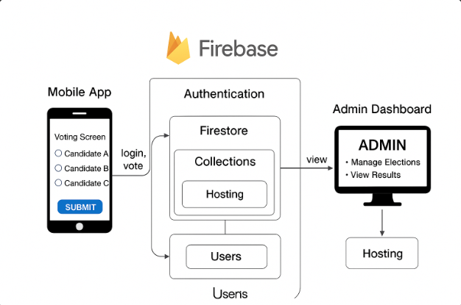
Figure 2

2.8.1 Login Screen
Purpose: To authenticate users before granting system access.
Design Description:
- Two input fields for Registration Number and Password.
- A “Login” button that connects to Firebase Authentication.
- A “Forgot Password?” link for password recovery.
- The university logo displayed at the top for branding.

Figure 3


Figure 4

2.8.2 Voter Dashboard
Purpose: To display available elections and navigation options.
Design Description:
- Simple top navigation bar with the user’s name and logout icon.
- List of available or active elections fetched from Firebase.
- “View Candidates” and “Vote Now” buttons beside each election title.
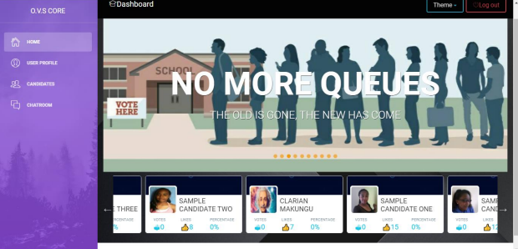
Figure 5

---------------------------------------

| Welcome, Karen Kiara [Logout] |

|-------------------------------------|

| Election: SAKU 2025 |

| [View Candidates] [Vote Now] |

|-------------------------------------|

| Election: Departmental Delegate |

| [View Candidates] [Vote Now] |

---------------------------------------

2.8.3 Voting Screen
Purpose: Allows users to cast their votes securely.
Design Description:
- Displays position title and candidate list with radio buttons.
- “Submit Vote” button at the bottom.
- Confirmation dialog before submission.
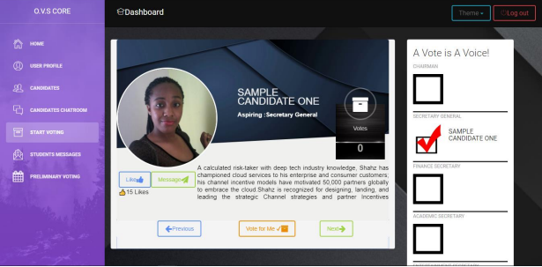
Figure 6

---------------------------------------

| Position: SAKU President |

|-------------------------------------|

| ( ) John Mwangi |

| ( ) Mercy Wambui |

| ( ) David Otieno |

|-------------------------------------|

| [Submit Vote] |

---------------------------------------

2.8.4 Results Screen
Purpose: Displays live results to authorized users.
Design Description:
- Results bar graph showing vote counts.
- Display of total votes, percentage per candidate, and turnout.
- Visible to administrators or after polls close


Figure 7

---------------------------------------

| SAKU 2025 ELECTION RESULTS |

|-------------------------------------|

| John Mwangi |||||||||| 45% |

| Mercy Wambui ||||||| 35% |

| David Otieno |||| 20% |

|-------------------------------------|

| Total Voters: 3,450 | Turnout: 78% |

---------------------------------------

CHAPTER THREE: REFERENCES
- Kabarak University. (2023). Online Student Voting System Overview. Retrieved from https://kabarak.ac.ke/evis
- University of Nairobi. (2023). Student Management Information System (SMIS) Portal. Retrieved from https://vote.uonbi.ac.ke/
- Kirinyaga University. (2024). ICT Department Reports on Student Online Voting System. Retrieved from https://www.ijssit.com/main/wp-content/uploads/2018/05/Student-Online-Voting-System.pdf
- Embu University. (2024). Student Online Voting Portal. Retrieved from https://departments.embuni.ac.ke/ict/index.php/66-record-breaking-e-voting-success-at-the-university-of-embu
- Nielsen, J. (2023). Usability Engineering in Human-Computer Interaction. Morgan Kaufmann Publishers.
- KCA University. (2025). SAKU Electoral Commission Guidelines and Constitution (2021 Amendment). Internal Document, KCA University.
- Google Developers. (2024). Firebase Documentation. Retrieved from https://firebase.google.com/docs
- Android Developers. (2024). Android Studio User Guide. Retrieved from https://developer.android.com/studio/
- https://www.studocu.com/row/document/kca-university/econometric/student-online-voting-system/21214639?origin=home-recent-1 International Journal of Social Science and Information Technology, ISSN 2412-0294, VolIV Issue V, May 2018
- https://ijrpr.com/uploads/V3ISSUE10/IJRPR7394.pdf International Journal of Research Publication and Reviews, Vol 3, no 10, pp 582-586, October 2022
- https://papers.ssrn.com/sol3/papers.cfm?abstract_id=4810277 Acharya, Kamal, Online Voting System Project (April 28, 2024).

4. Qualifications
The development of the proposed KCA University Online Student Election System will be undertaken by Karen Kiara, a student at KCA University pursuing a Bachelor of Science in Information Technology. The developer possesses a solid foundation in both theoretical and practical aspects of software engineering, system design, and mobile development.
Over the course of study, the developer has successfully completed relevant coursework and practical projects that directly support the design and implementation of this system. These include:
- Mobile Programming: Acquired proficiency in developing Android applications using Java and Android Studio.
- Database Systems: Gained experience in designing and managing databases using MySQL and Firebase Firestore.
- Web Systems and Design: Developed web applications using HTML, CSS, PHP, and JavaScript, which inform the system’s frontend logic.
- Network Systems and Security: Understanding of secure data transmission, authentication, and encryption — essential for protecting voter data.
- Software Engineering Principles: Ability to apply software development life cycle (SDLC) methods, documentation standards, and version control practices.
- Project Management: Knowledge of planning, scheduling, and executing system development tasks efficiently.
The developer also has experience using Firebase, GitHub, and Android Studio Emulator for testing and deployment. This technical background ensures that the system will be implemented following best practices in mobile application development and cloud computing.
Furthermore, the developer demonstrates strong analytical, problem-solving, and teamwork skills, which are critical to managing complex software projects and collaborating with university staff and technical advisors throughout the development process.

